## User Study Data

[Individual Interviews](https://drive.google.com/drive/folders/19GgEeS1T-NJR43JmhFhEm8wqWPvXf3f9?usp=sharing) including transcripts, open coding, notes and signed consent forms. This is a link to a google drive folder containing all our interview data.

## Qualitative Analysis

### Open Coding & Affinity Mapping -> [Miro Board](https://miro.com/app/board/uXjVIX9ZuiQ=/?share_link_id=489215239769)

### Themes & Implications of Design

* Theme: People prefer eating in restaurants more than ordering online.
  + Implication: Location of places must be taken into account, as well as pictures and other elements that describe and illustrate the restaurant or place being shown.
* Theme: People prefer having reviews on restaurants and usually utilize them, but they might not show the full picture.
  + Implication: Include reviews of users to these places and their food, and make the process of reviewing more specialized to the context of trying new foods.
* Theme: People like trying new types of food, as well as new restaurants.
  + Implication: Store what the user has already tried or what places they’ve been to, and when recommending, push more “novel” options first to encourage that behavior.
* Theme: People have many sources to look for new food/restaurants in different places, and not all of them turn out to be helpful.
  + Implication: Have our solution be the centralized source for finding new places, having the helpful information while discarding the unhelpful ones.

## Quantitative Analysis

While conducting user research, the interviewees completed a survey in addition to the interview itself. Each figure is the users’ response to those surveys. Below is a description and analysis of each figure.

Figure 1

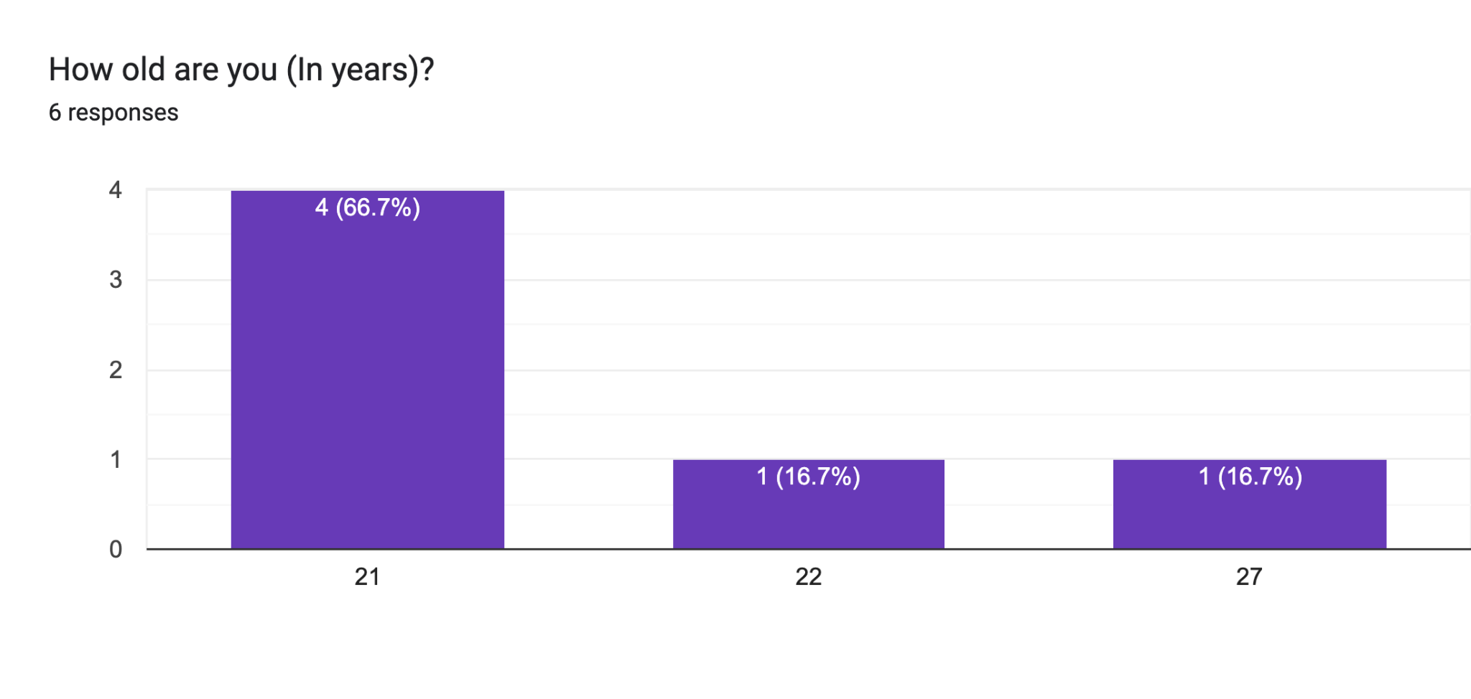

Figure 2

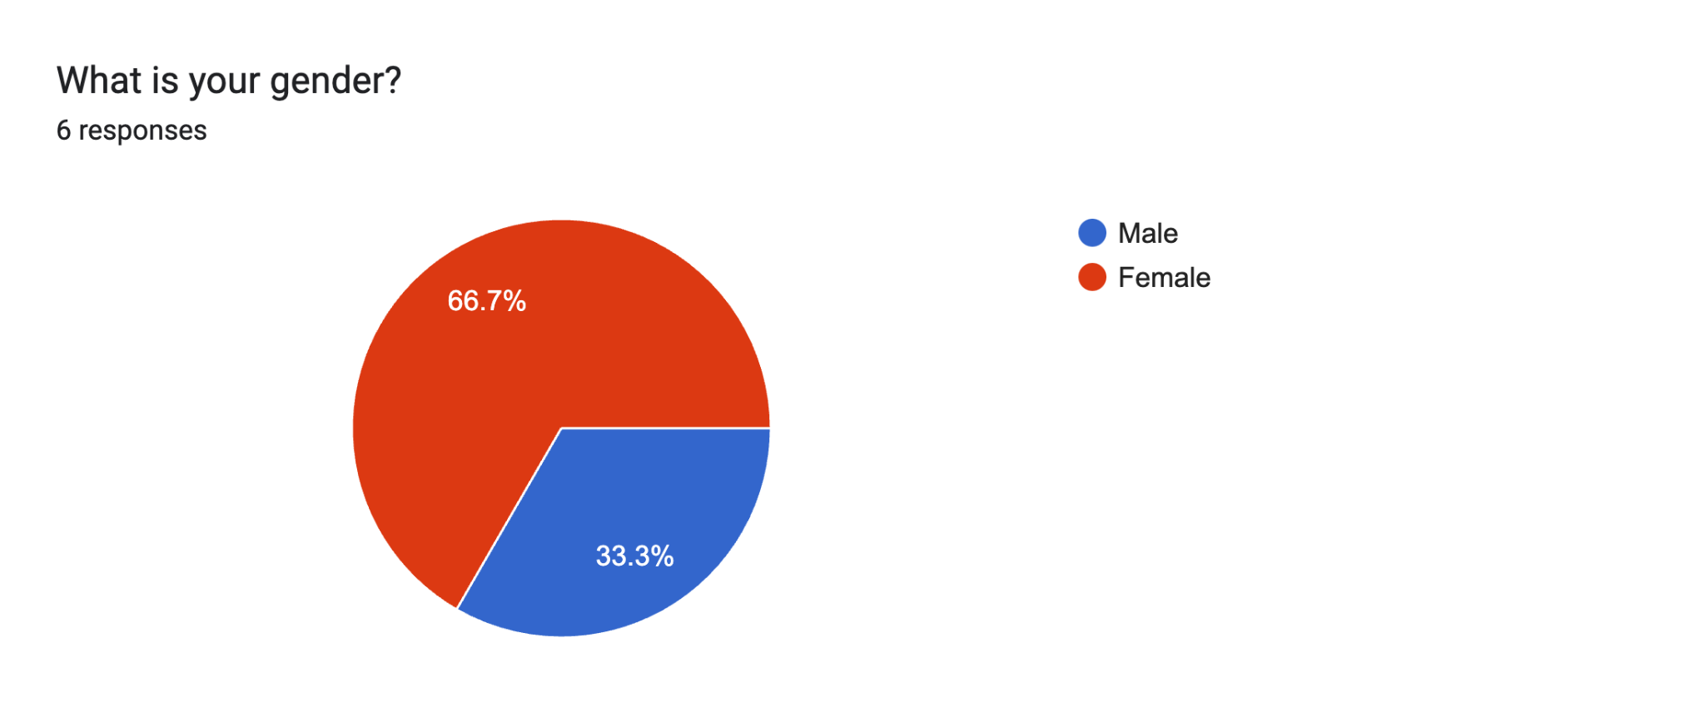

Figure 3

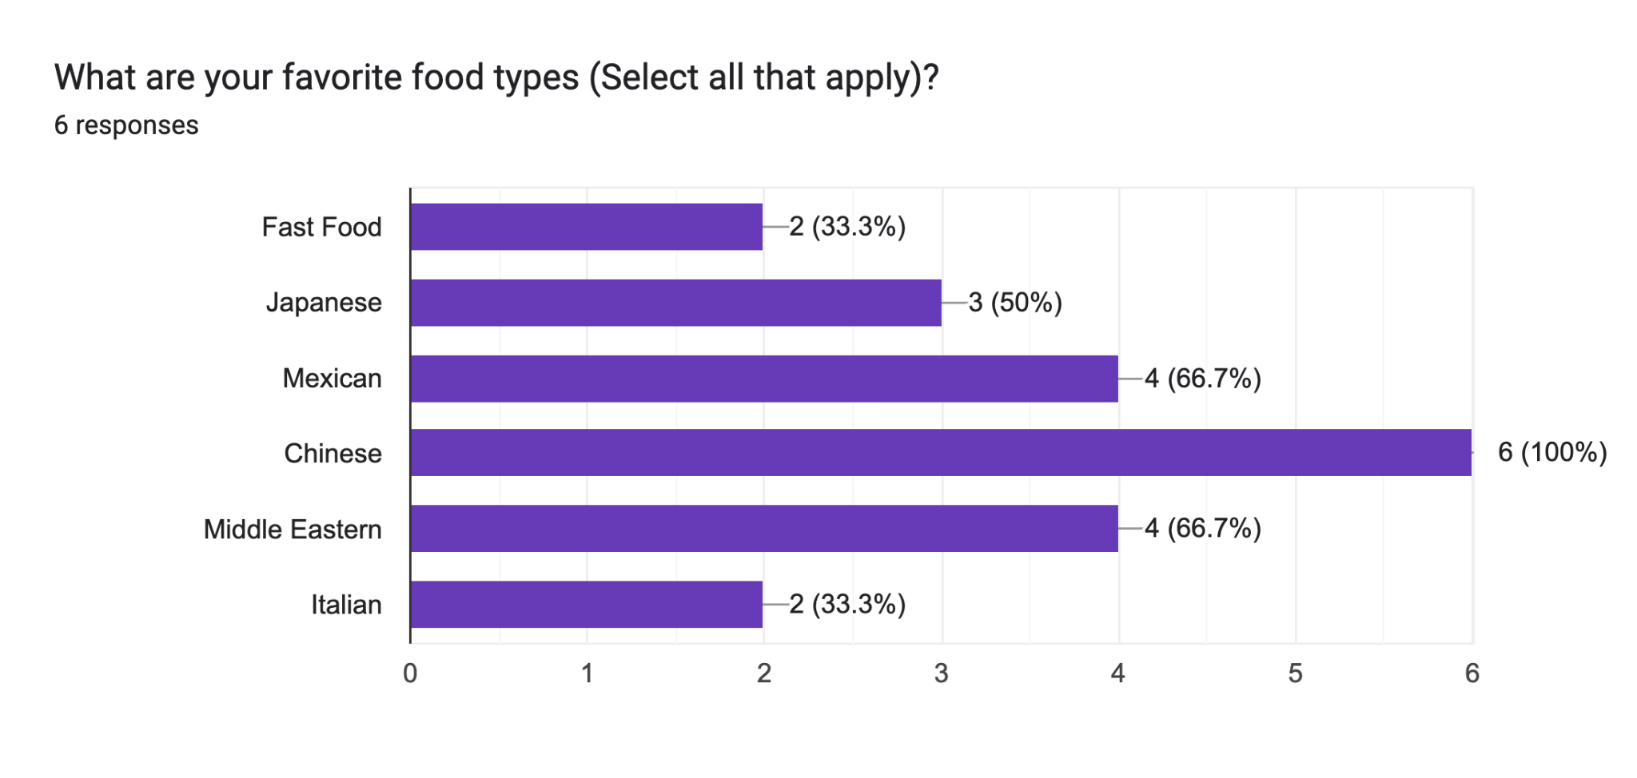

Pretty diverse distribution, fast food is lower than expected.

Figure 4

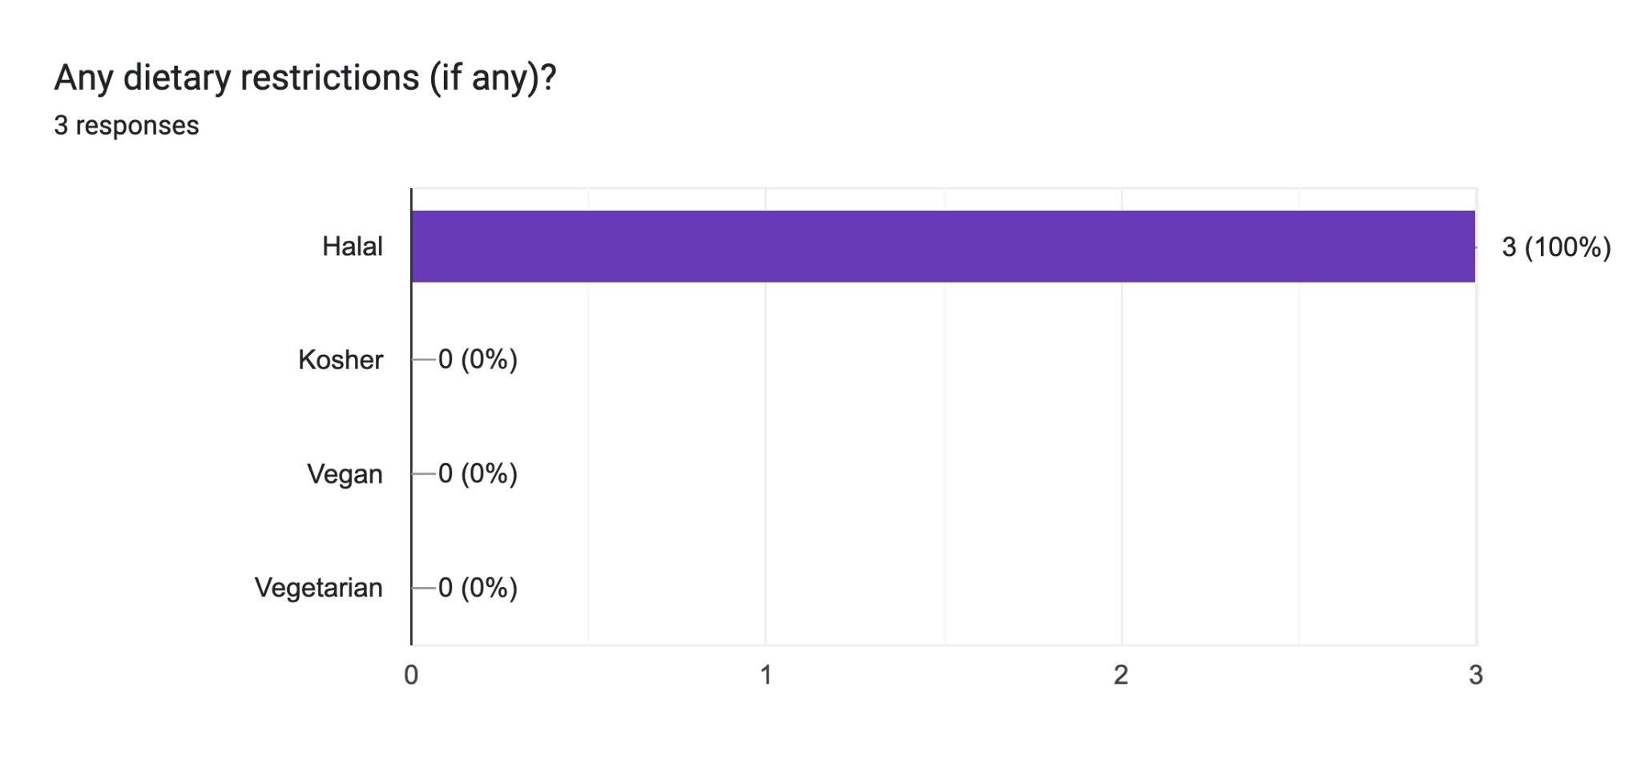

Figure 5

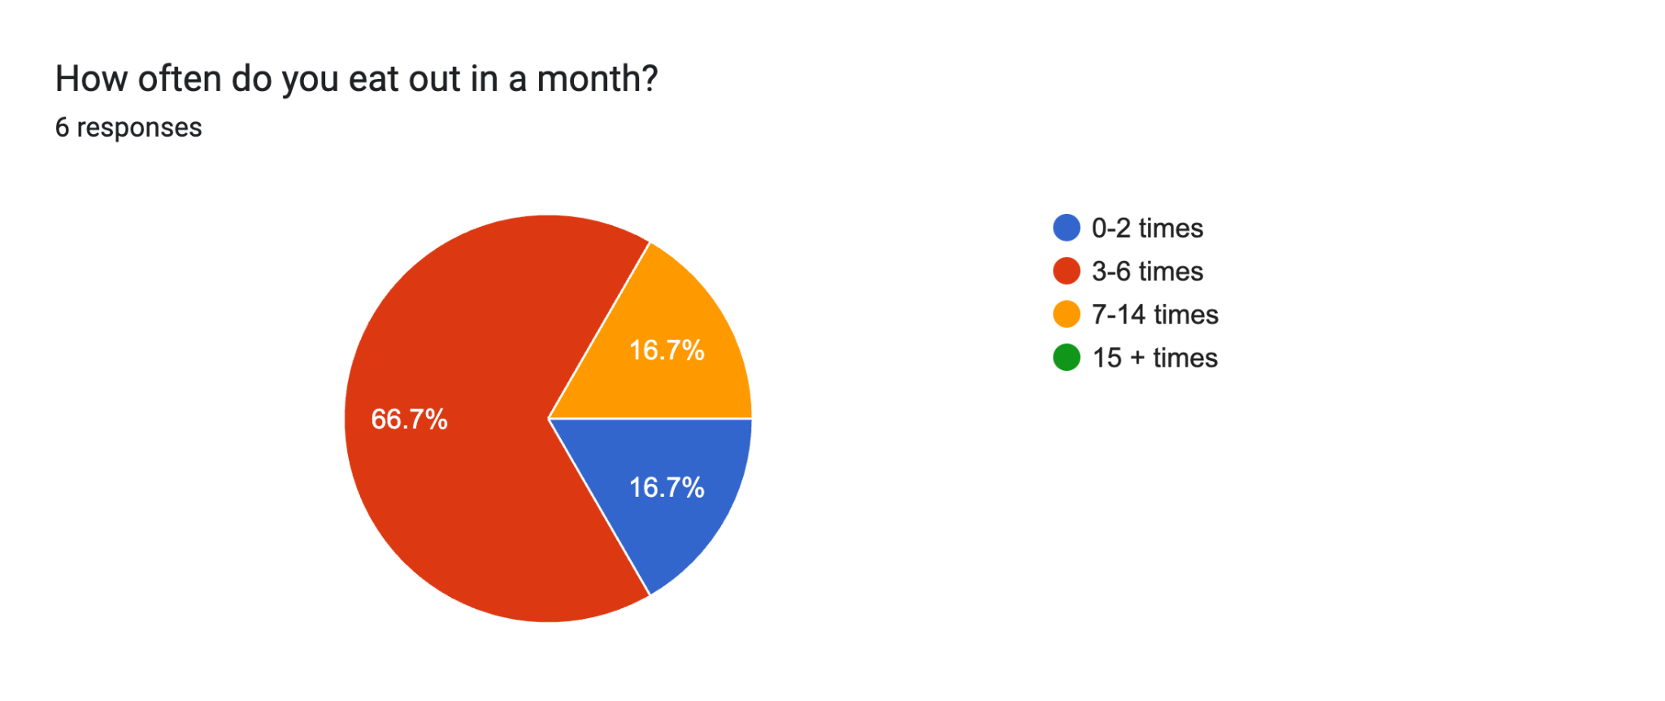

Figure 6

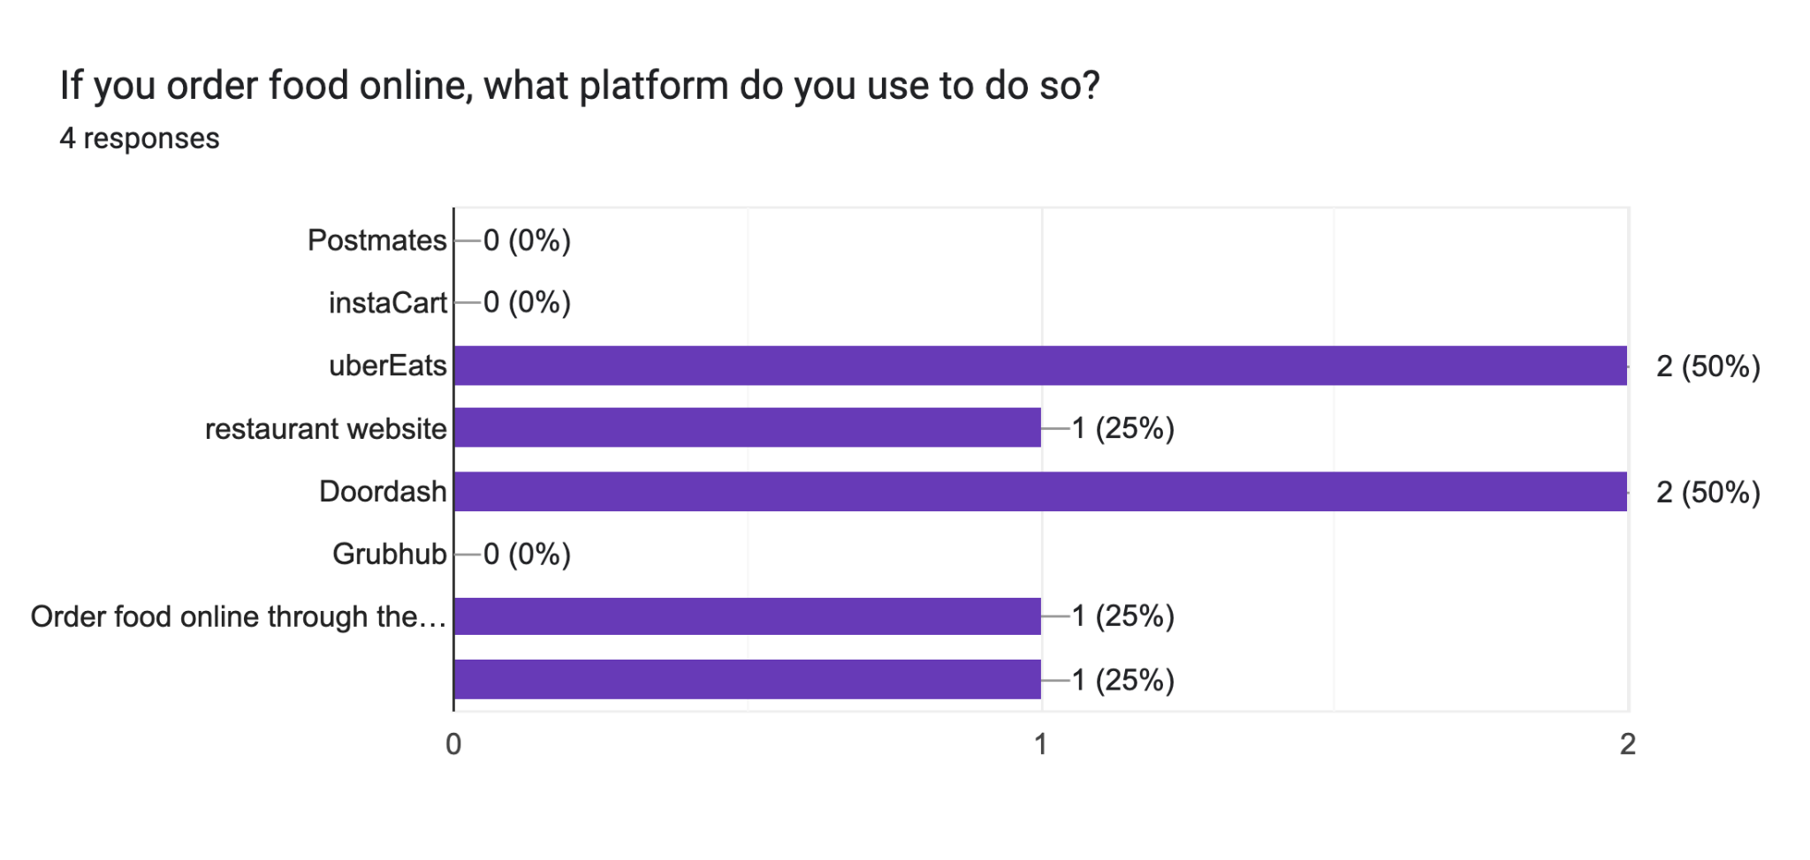

Figure 7

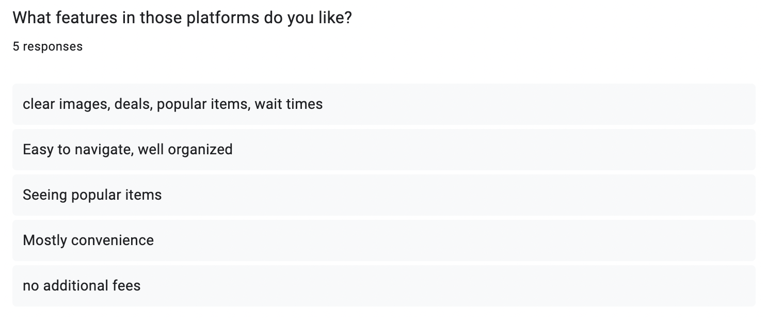

This question and its answers will help us infer what services users prefer in other, similar interfaces and alternatives.

## Interpretation of Figures

* Figure 1: Age distribution
  + The majority of respondents are 21 years old (66.7%), with another respondent at 22 years old (16.7%) and the other at 27 years old (16.7%). This suggests that most of the interviewees are within the same age group.
  + It is probably biased by the fact that we interviewed people that were colleagues/acquaintances in one way or another (co-worker for example) and thus they are more likely to be around our age.
  + The age range can impact user preferences as younger users are more likely to use social media as a tool to find food suggestions and prefer mobile friendly applications.
  + Our key takeaway from this was that our application should prioritize a user-friendly, modern interface that draws on social media platforms and reviews to make it easy to engage with.
* Figure 2: Gender distribution
  + The majority of respondents are female (66.7%) and the rest of respondents are male (33.3%). This distribution suggests that food and restaurant preferences could be influenced by gender based behaviors.
  + The key takeaway is to consider differences in dining priorities and preferences between gender groups and make personalized recommendations based on that.
* Figure 3: Favorite food types
  + This figure illustrates users' food preferences and demonstrates that users have diverse food preferences. Chinese cuisine is the most popular (100%), mexican and middle eastern foods are also preferred by a majority (66.7%), but fast food/italian had lower preference levels (33.3%). This data suggests that users lean toward more flavorful, diverse cuisines, and may appreciate a variety of ethnic restaurants.
  + Our key takeaway is that this application should highlight many international cuisines and give restaurant filtering options based on what type of cuisine they are looking for (i.e mexican, chinese, middle eastern, east african, indian, etc…)
* Figure 4: Dietary Restrictions
  + Among those that responded to this question, 100% of them noted they follow a Halal diet indicating that dietary restrictions and preferences play a big role in their food choices and where they eat.
  + The key takeaway is that the application should prioritize dietary restrictions/ allergy filtering options making sure that a user can easily filter restaurants based on their dietary needs (i.e halal, kosher, vegan, and vegetarian). Making these selections easily accessible can improve user trust.
* Figure 5: Frequency of eating out
  + Most respondents said that they eat out 3-6 times per month (66.7%) which showcases that dining out could be considered an occasional activity rather than a more frequent one. Only 16.7% of respondents said they eat out 7-14 times a week, and the rest stated they eat out 0-2 times a week (16.7%). This reinforces that users could be selective on when they eat out, and is likely not a daily habit.
  + Adding to this, people we interviewed don’t eat out too often, reinforcing that they do it more as a “special occurrence” than a recurring or frequent event.
  + The key takeaway from this data is to show more recommendations for special occasions, trending spots, and even group discounts. We should be focusing on quality over quantity, and making sure users get a great experience even if they only eat out once in a while.
* Figure 6: Online Ordering Preferences
  + Most respondents either chose DoorDash or UberEats (50% each), and other respondents preferred using restaurant websites (25%). Other food delivery services like GrubHub, PostMates, InstaCart weren’t used at all.This suggests that ordering food online is not as common as we first thought amongst people.

Putting this together with the other observed interview data and notes, it shows that dine in experiences are preferred over online ordering.

* + Our key takeaway was instead of prioritizing and advertising food delivery, we will focus on in person dining, location based recommendations, and more social settings.
* Figure 7: Features Users Like on Online Platforms
  + Respondents listed key platform features they value in other online food based platforms and many said they value easy navigation and visibility, being able to see popular menu items, and having it be convenient. This shows that users prefer simplicity, transparency, and convenience when it comes to food ordering applications.
  + Our key takeaway is that our application should incorporate all of these preferences including high quality menu previews and images, a user friendly and easily visible interface, popular and trending food locations drawing on social media, and real time restaurant wait times and deals.